Project Furtails build log
By White Fossa aka Artyom Vetrov
AGPL v3+

1) Print vertebrae in enough quantity, in my case it was 35, including tail tip.
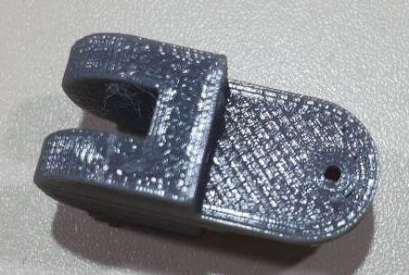

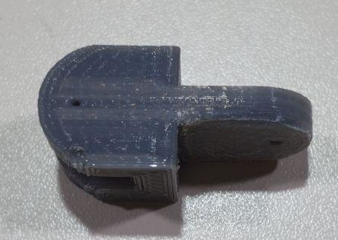

2) Drill upper holes in vertebrae with 1.2mm drill (depends on paperclips wires diameter from 3 step).
3) Get some paperclips (thicker and stronger is better), unbend them and make them pretty straight using hammer and anvil (my paperclips was with curved wires).
4) Cut paperclips wires to 75mm length sections and make loops on one side using small pliers.

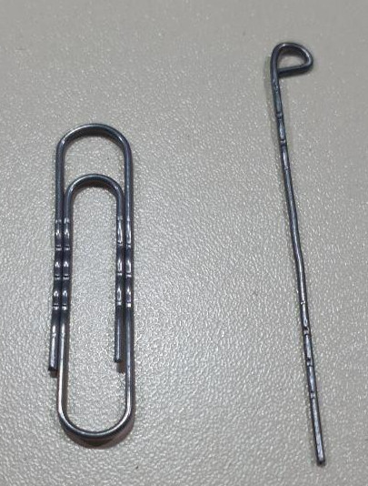

5) Connect vertebrae using wires from the step 4 bend the loop on the second end after inserting each wire.
6) Glue wires to vertebrae using cyanacrilate (aka “Super Glue”). Be careful to not glue vertebrae together.
DO NOT attach tailtip vertebra for now.

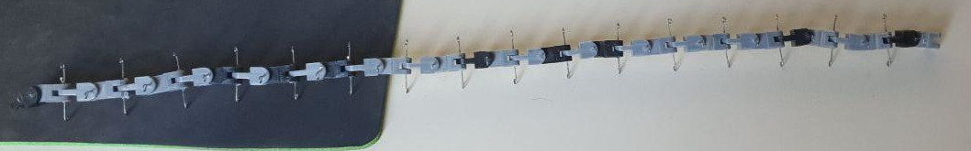

Servos: Turnigy TGY-5902

